Cause for concern form / record of safeguarding interventions by League and Club Welfare Officers

Date: October 2020 Version No 1

Section A:
Name:

Address:

Date of birth:

Name of club and age group:

Name of welfare officer completing the form:

Date of issue/incident that has caused concern:

Date form completed:

Details of Parent/ carer:

Concern in relation to (please tick) adult ☐ child ☐ both ☐
which links with child protection plans when
there are concerns about neglect)

Section B: Nature of Concern
(Please tick relevant issue that has led to the cause for concern)
Risk to self ☐ Risk to others ☐ Risk from others ☐

Is the concern:
Allegation ☐ Poor Practice ☐ Disclosure ☐
Nature of the concern:
Breach of confidentiality/other data protection breach ☐ Child exploitation ☐
(inc. criminal & sexual)
Conditions in the home ☐ Cyber/on-line bullying ☐ Drug dealing ☐
Grooming ☐ Hate crime ☐ Knife/other weapon crime ☐ Overdose ☐ Self-harm ☐ Self neglect ☐ Substance misuse ☐ Low Mood ☐ Trafficking ☐
Other (please specify)

NOTE: Please refer to the RFL Safeguarding Policy to ensure any concerns which must be reported to the RFL Safeguarding Manager are done so promptly.

Section C: Brief details about the incident/concern/allegation

Please use the body diagram to indicate any area(s) of injury or mark(s) seen.
(To indicate on the body diagram where any areas of injury or marks have been seen; please use ‘insert text box’ on the diagram and then use this to indicate the injury or mark. The inserted text box can be shaded in using ‘Format tab’ and selecting ‘Shape fill’ whilst the computer cursor is on the text box).

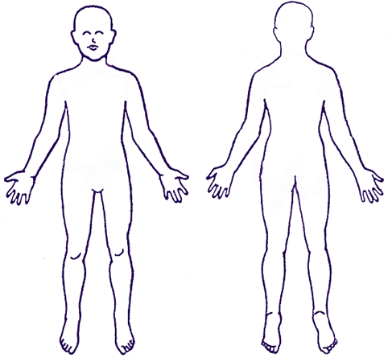

Any witnesses to incident:

Section D: Details of action taken/planned

Referral made/to be made:
Refer to  Safeguarding manager ☐ | Date referred |  | Safeguarding case no  (if known)

Section E: Making safeguarding personal
What would the individual/ family like to see as the outcome as a result of the safeguarding alert being made? (i.e. difference wanted/desired)
What does the person (adult/child at risk/that you are raising the concern about) want to happen or the outcome to be (if known), please give details of their wishes. Please remember, this is not about your views, but the young persons or parent/ carers own.

What else needs to be done to keep the child / young person/ vulnerable adult safe?

What is the child / young person/ vulnerable adult saying to you about their experience / the situation & the impact that it is having on them? What do they want to see change?
This aspect helps you to capture the voice of the child / young person/ vulnerable adult & things from their perspective.

Section F: Comments and Follow up
Comments by League Welfare Officer including additional action required

League Welfare Officer Name Date:
Comments by Safeguarding Manager including additional action that may be required

Safeguarding Manager Name: Date:

Section G: Outcome of interventions, including any meetings relating to the concern

Please send updated form to the Safeguarding Manager Kerry Simmons at kerry.simmons@rfl.co.uk

